QSFP28 -4*SFP28 Active optical cabel
(AOC)

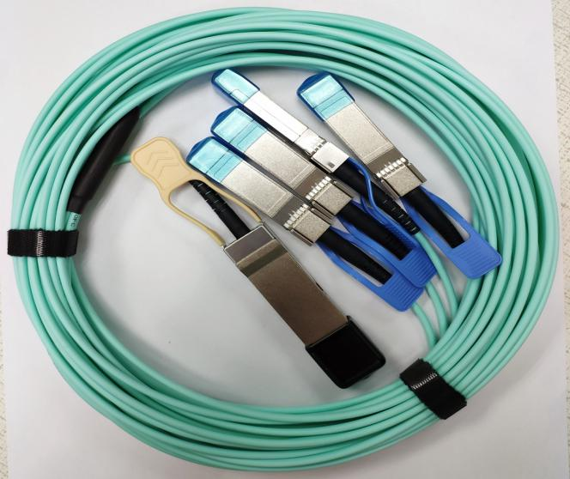

Document NO. | Draft by | Review by | Approved by
GL-DCS-QSFS0004 | Danny Chen | Geoge Huang | Kevin Lin

Description:
QSFP28-4SFP28-AOC active optical cable, integrated four data channels, the total bandwidth of 100Gbps. 4 transmission channels, each channel can run at 25.3125 Gbps. QSFP + to 4x SFP + AOC cables are 100GBase QSFP + hybrid cables. One end is a QSFP + optical connector and the other end is a 4 SFP + optical connector. Transmission distance of not more than 100 meters. The fiber optic cable is a high-performance module for short-range multi-channel data communications and interconnect applications.

Features
- Support 4x25GBASE-SR application
- Compliant to QSFP28 MSA SFF-8636 and SFP28 MSA SFF-8431 and SFF- 8472
- Multi rate of up to 25.78125Gbps per lane
- Transmission distance up to 50m
● +3.3V single power supply
- Low power consumption
- UL certification cables (optional)
- Operating temp Commercial: 0°C to +70 °C
- RoHS compliant

Applications
- 4x25Gbe-SR
- Other optical links
Absolute Maximum Ratings
Table1- Absolute Maximum Ratings
Parameter | Symbol | Min. | Typical | Max. | Unit | Notes
Supply Voltage | Vcc₃ | -0.5 | - | +3.6 | V
Storage Temperature | T_{s} | -10 | - | +70 | °C
Operating Humidity | RH | +5 | - | +85 | % | 1
Note: 1 No condensation
Recommended Operating Conditions
Table 2- Recommended operating Conditions
Parameter | Symbol | Min. | Typical | Max. | Unit | Notes
Operating Temperature | T_{C} | 0 | - | +70 | °C
Power Supply Voltage | Vcc | 3.14 | 3.3 | 3.47 | V
Power Dissipation per QSFP28 | Pd | - | - | 2.5 | W
Power Dissipation per SFP28 | Pd | - | - | 1.0 | W | 1
Bit Rate per Lane | BR | 10.3125 | 25.78125 | - | Gbps
Note: 1 Per terminal

Electrical Characteristics
Table 3- Electrical Characteristics for QSFP28
Parameter |  | Symbol | Min. | Typ. | Max. | Units | Notes
ModSelL | Module Select | VOL | 0 | - | 0.8 | V
 | Module Unselect | VOH | 2.5 | - | VCC | V
LPMode | Low Power Mode | VIL | 0 | - | 0.8 | V
 | Normal Operation | VIH | 2.5 | - | V_{CC}+0.3 | V
ResetL | Reset | VIL | 0 | - | 0.8 | V
 | Normal Operation | VIH | 2.5 | - | V_{CC}+0.3 | V
ModPrsL | Normal Operation | VOL | 0 | - | 0.4 | V
IntL | Interrupt | VOL | 0 | - | 0.4 | V
 | Normal Operation | VoH | 2.4 | - | VCC | V
Electrical Transmitter Characteristics
Differential Date Input Swing |  | Vin,P-P | 200 | - | 1600 | mV
Output Differential Impedance |  | ZIN | 90 | 100 | 110 | Ω
Electrical Receiver Characteristics
Differential Data Output Swing |  | Vout | 200 | - | 800 | mV_{PP}
Bit Error Rate |  | BER |  |  | E-12 |  | 1
Input Differential Impedance |  | Z_{D} | 90 | 100 | 110 | Ω
Note: 1 PRBS2^31-1@25.78125Gbps
Table 4- Electrical Characteristics for SFP28
Parameter |  |  | Symbol |  | Min. | Typ. | Max. | Units |  | Notes
Electrical Transmitter Characteristics
Differential Data Input Swing |  |  | Vin,P-P |  | 200 | - | 1600 |  | mV_{PP}
Input Differential Impedance |  |  | ZIN |  | 90 | 100 | 110 |  | Ω
Tx_Fault | Normal Operation |  | VOL |  | 0 | - | 0.8 |  | V
 | Transmitter Fault |  | VOH |  | 2.0 | - | VCC |  | V
Tx_Disable | Normal Operation |  | VIL |  | 0 | - | 0.8 |  | V
 | Laser Disable |  | VIH |  | 2.0 | - | V_{CC}+0.3 |  | V
Electrical Receiver Characteristics
Differential Date Output |  |  |  | Vout | 400 | - | 800 | mV
Bit Error Rate |  |  |  | BER | - | - | E-12 | -
Output Differential Impedance |  |  |  | Z_{D} | 90 | 100 | 110 | Ω
Rx_LOS |  | Normal Operation |  | VOL | 0 | - | 0.8 | V
 |  | Lose Signal |  | VoH | 2.0 | - | VCC | V

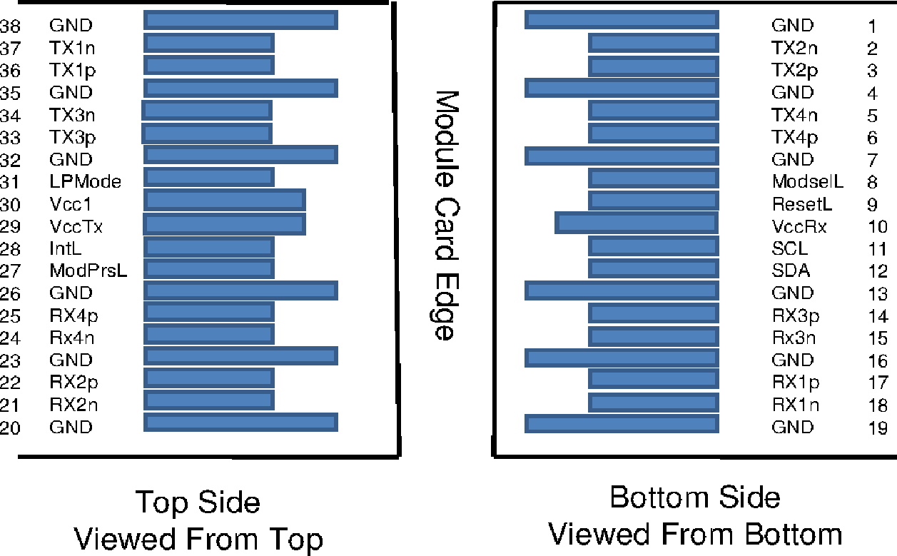
Pin arrangement
Figure 1, Pin View for QSFP28

Table 5- Pin Function Definitions for QSFP28
Pin | Symbol | Name/Description | Notes
1 | GND | Ground | 1
2 | Tx2n | Transmitter Inverted Data Input
3 | Tx2p | Transmitter Non-Inverted Data Input
4 | GND | Ground | 1
5 | Tx4n | Transmitter Inverted Data Input
6 | Tx4p | Transmitter Non-Inverted Data Input
7 | GND | Ground | 1
8 | ModSelL | Module Select
9 | ResetL | Module Reset
10 | Vcc Rx | +3.3V Power Supply Receiver
11 | SCL | 2-wire serial interface clock
12 | SDA | 2-wire serial interface data
13 | GND | Ground | 1
14 | Rx3p | Receiver Non-Inverted Data Output
15 | Rx3n | Receiver Inverted Data Output
16 | GND | Ground | 1
17 | Rx1p | Receiver Non-Inverted Data Output
18 | Rx1n | Receiver Inverted Data Output
19 | GND | Ground | 1
20 | GND | Ground | 1
21 | Rx2n | Receiver Inverted Data Output
22 | Rx2p | Receiver Non-Inverted Data Output
23 | GND | Ground | 1
24 | Rx4n | Receiver Inverted Data Output

Pin | Symbol | Name/Description | Notes
25 | Rx4p | Receiver Non-Inverted Data Output
26 | GND | Ground | 1
27 | ModPrsL | Module Present
28 | IntL | Interrupt
29 | Vcc Tx | +3.3V Power supply transmitter
30 | Vcc1 | +3.3V Power supply
31 | LPMode | Low Power Mode
32 | GND | Ground | 1
33 | Tx3p | Transmitter Non-Inverted Data Input
34 | Tx3n | Transmitter Inverted Data Input
35 | GND | Ground | 1
36 | Tx1p | Transmitter Non-Inverted Data Input
37 | Tx1n | Transmitter Inverted Data Input
38 | GND | Ground | 1
Note: 1. Circuit ground is internally isolated from chassis ground.
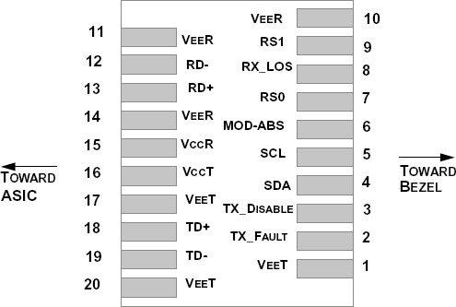

Table 6-Pin Function Definitions
Figure 2, Pin View for SFP28

Pin | Symbol | Name/Description | Notes
1 | VEET | Module Transmitter Ground | 1
2 | TX_FAULT | Module Transmitter Fault | 2
3 | TX_DISABLE | Transmitter Disable; Turns off transmitter laser output | 3
4 | SDA | 2-Wire Serial Interface Data Line (MOD-DEF2)
5 | SCL | 2-Wire Serial Interface Clock (MOD-DEF1)
6 | MOD_ABS | Module Absent, connected to V_{EE}T or V_{EE}R in the module | 2
7 | RS0 | Rate Select 0, optionally controls SFP+ module receiver | 4
8 | RX_LOS | Receiver Loss of Signal Indication (In FC designated as Rx_LOS and in Ethernet designated as NOT Signal Detect) | 2
9 | RS1 | Rate Select 1, optionally controls SFP+ module transmitter | 4

Pin | Symbol | Name/Description | Notes
10 | V_{EE}R | Module Receiver Ground | 1
11 | V_{EE}R | Module Receiver Ground | 1
12 | RD- | Receiver Inverted Data Output
13 | RD+ | Receiver Non-Inverted Data Output
14 | V_{EE}R | Module Receiver Ground | 1
15 | V_{CC}R | Module Receiver 3.3 V Supply
16 | V_{CC}T | Module Transmitter 3.3 V Supply
17 | V_{EE}T | Module Transmitter Ground | 1
18 | TD+ | Transmitter Non-Inverted Data Input
19 | TD- | Transmitter Inverted Data Input
20 | V_{EE}T | Module Transmitter Ground | 1
Note:
- The module ground pins are isolated from the module case.
- The pins shall be pulled up with 4.7K-10Kohms to a voltage between 3.14V and 3.46V on host board.
- The pin is pulled up to VCCT with a 4.7K-10KΩ resistor in the module.
- See SFF-8472 Rev12.2 Table 10-2.

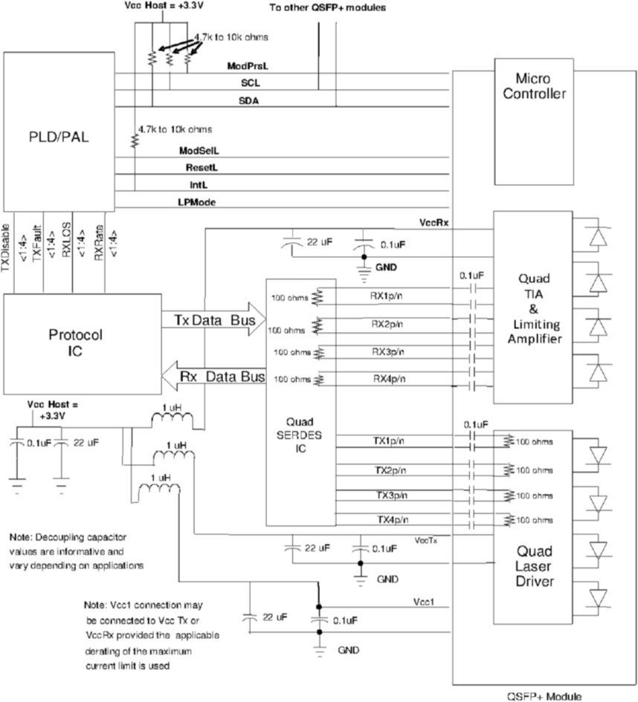
Recommended Circuit
Figure 3, Recommended Interface Circuit for QSFP28

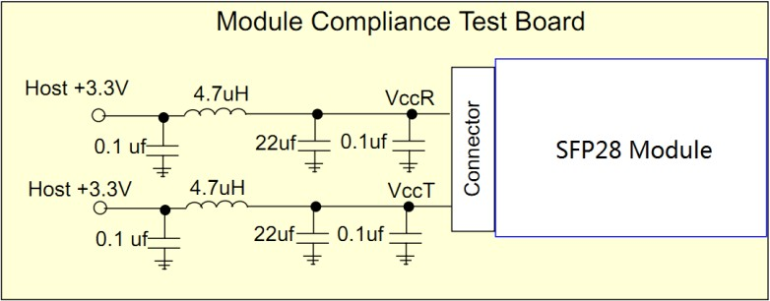
Figure 4, Recommended Host Board Power Supply Circuit for SFP28
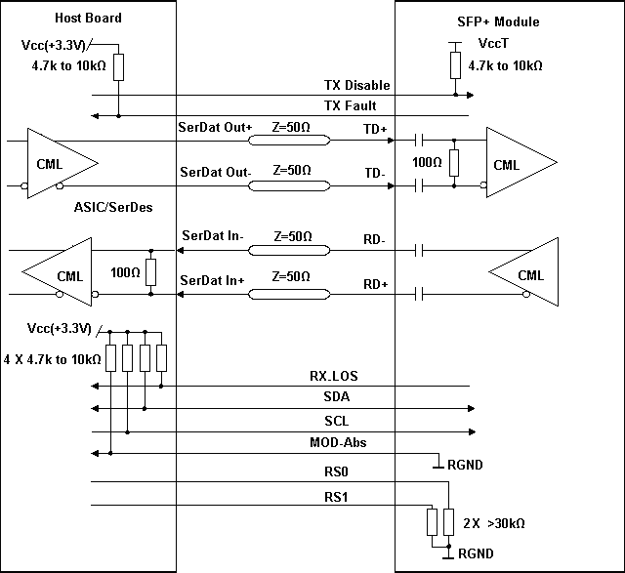
Figure 5, Recommended Interface Circuit for SFP28

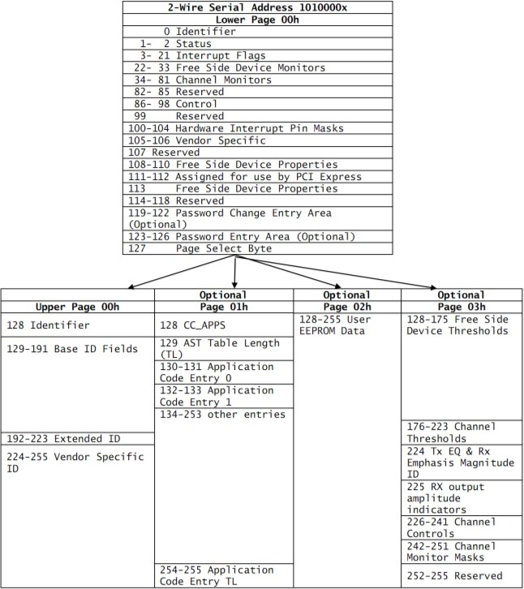
Monitoring Specification
Figure 6, Memory Map for QSFP28

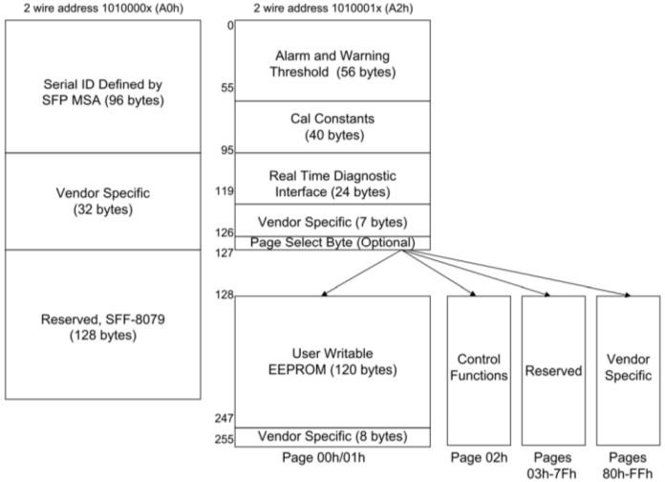
Figure 7, Memory Map for SFP28

Mechanical
Unit mm
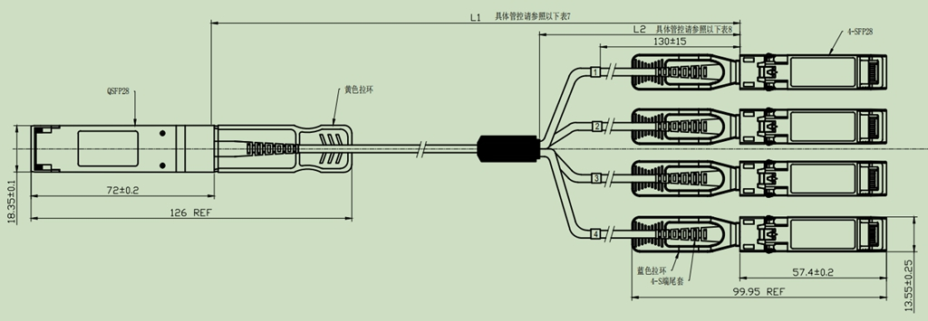

Figure 8, Mechanical Diagram

Table 7- Cable Length
Cable Length L1（Unit: m） | Tolerant（Unit: cm）
≤1.0 | +5/-0
1.0＜L≤4.5 | +15/-0
4.5＜L≤14.5 | +30/-0
＞14.5 | +2%/-0

Table 8- Breakout Cable Nominal Length
Total Length  L1 (Unit: m) | Breakout Point Measured from SFP  L2(Unit: m)
1 | 0.7
2 | 1.4
3 | 2
≥5 | 3

Warnings
Handling Precautions: This device is susceptible to damage as a result of electrostatic discharge (ESD).
A static free environment is highly recommended. Follow guidelines according to proper ESD procedures.
Laser Safety: Radiation emitted by laser devices can be dangerous to human eyes. Avoid eye exposure to direct or indirect radiation.

