100G QSFP28 Direct Attach Cable

(DAC)

Datasheet
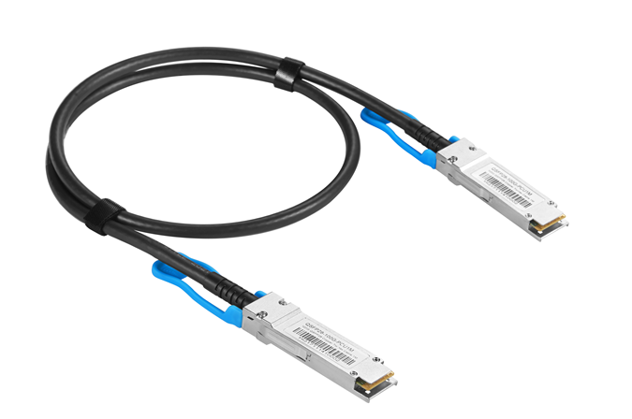

General Description
QSFP28 Direct Attach Cables are compliant with the SFF-8665 specifications. Various choices of wire gauge are available from 30 to 24 AWG with various choices of cable length (up to 5m).

Features
- Compliant with SFF- 8665
- Up to 28.3125Gbps data rate per channel
- Up to 5m transmission
- Operating temperature: 0~70℃
- Single 3.3V power supply
- RoHS compliant

Benefits
- Cost-effective copper solution
- Lowest total system power solution
- Lowest total system EMI solution
- Optimized design for Signal Integrity

Applications
- 100G Ethernet

Pin Function Definition

Pin | Logic | Symbol | Description
1 |  | GND | Ground
2 | CML-I | Tx2n | Transmitter Inverted Data Input
3 | CML-I | Tx2p | Transmitter Non-Inverted Data Input
4 |  | GND | Ground
5 | CML-I | Tx4n | Transmitter Inverted Data Input
6 | CML-I | Tx4p | Transmitter Non-Inverted Data Input
7 |  | GND | Ground
8 | LVTTL-I | ModSelL | Module Select
9 | LVTTL-I | ResetL | Module Reset
10 |  | Vcc Rx | +3.3V Power Supply Receiver
11 | LVCMOS-  I/O | SCL | 2-wire serial interface clock
12 | LVCMOS-  I/O | SDA | 2-wire serial interface data
13 |  | GND | Ground
14 | CML-O | Rx3p | Receiver Non-Inverted Data Output
15 | CML-O | Rx3n | Receiver Inverted Data Output
16 |  | GND | Ground
17 | CML-O | Rx1p | Receiver Non-Inverted Data Output
18 | CML-O | Rx1n | Receiver Inverted Data Output
19 |  | GND | Ground
20 |  | GND | Ground
21 | CML-O | Rx2n | Receiver Inverted Data Output
22 | CML-O | Rx2p | Receiver Non-Inverted Data Output
23 |  | GND | Ground
24 | CML-O | Rx4n | Receiver Inverted Data Output
25 | CML-O | Rx4p | Receiver Non-Inverted Data Output
26 |  | GND | Ground
27 | LVTTL-O | ModPrsL | Module Present
28 | LVTTL-O | IntL | Interrupt
29 |  | Vcc Tx | +3.3V Power supply transmitter
30 |  | Vcc1 | +3.3V Power supply
31 | LVTTL-I | LPMode | Low Power Mode
32 |  | GND | Ground
33 | CML-I | Tx3p | Transmitter Non-Inverted Data Input
34 | CML-I | Tx3n | Transmitter Inverted Data Input
35 |  | GND | Ground
36 | CML-I | Tx1p | Transmitter Non-Inverted Data Input
37 | CML-I | Tx1n | Transmitter Inverted Data Input
38 |  | GND | Ground

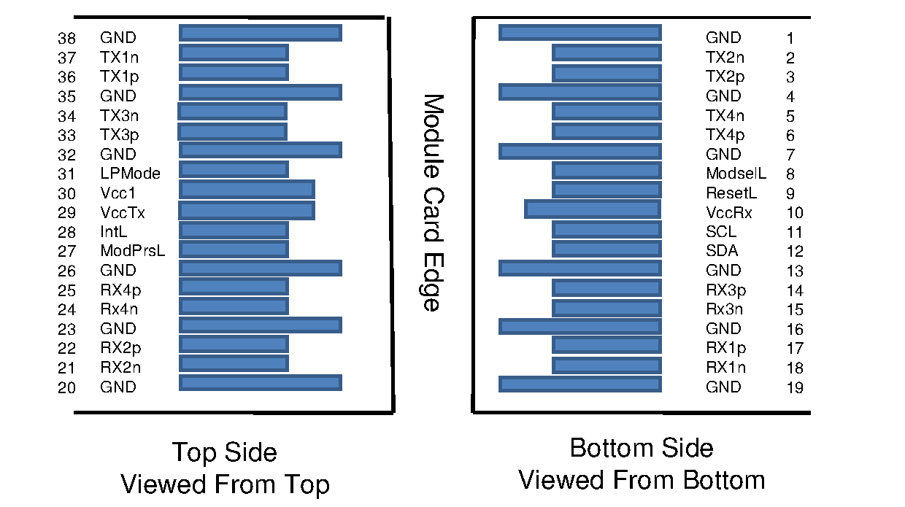

General Product Characteristics

QSFP+ DAC Specifications
Number of Lanes | Tx & Rx
Channel Data Rate | 28.3125 Gbps
Operating Temperature | 0 to + 70°C
Storage Temperature | -40 to + 85°C
Supply Voltage | 3.3 V nominal
Electrical Interface | 38 pins edge connector
Management Interface | Serial, I2C

High Speed Characteristics

Parameter | Symbol | Min | Typ | Max | Units | Notes
Differential Impedance | Zd | 90 | 100 | 110 | Ω
Differential Input Return Loss | SDDXX | <-12+2* SQRT (f) with f in GHz |  |  | dB | 0.01~4.1GHz
 |  | <-6.3+13*  Log10/(f/5.5) with f in GHz |  |  | dB | 4.1~19GHz
Common Mode Output Return Loss | SCCXX | < -7+1.6*f with f in GHz |  |  | dB | 0.01~12.89GHz
 |  |  |  | -3 | dB | 12.89~19GHz
Difference Waveform Distortion Penalty | dWDPc |  |  | 6.75 | dB
VMA Loss | L |  |  | 4.4 | dB
VMA Loss to Crosstalk Ratio | VCR | 32.5 |  |  | dB

Mechanical Specifications
The connector is compatible with the SFF-8665 specification.

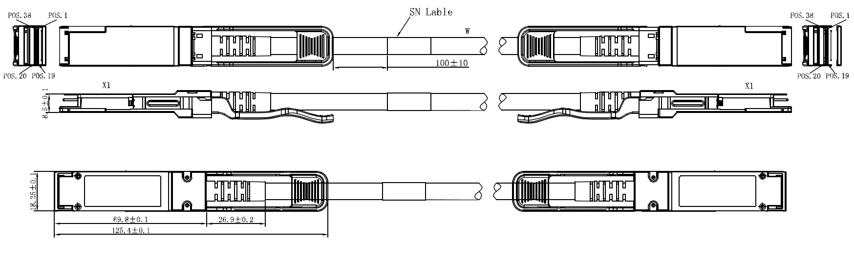

Length (m) | Cable AWG
1 | 30
3 | 26
5 | 26/24

Regulatory Compliance

Feature | Test Method | Performance
Electrostatic Discharge (ESD) to the Electrical Pins | MIL-STD-883C Method 3015.7 | Class 1(>2000 Volts)
Electromagnetic Interference(EMI) | FCC Class B | Compliant with Standards
 | CENELEC EN55022 Class B
 | CISPR22 ITE Class B
RF Immunity(RFI) | IEC61000-4-3 | Typically Show no Measurable Effect from a 10V/m Field Swept from 80 to 1000MHz
RoHS Compliance | RoHS Directive 2011/65/EU and it's Amendment Directives 6/6 | RoHS 6/6 compliant

