HD MINISAS-HD MINISAS Specification

Mini-SAS HD x4 to Mini-SAS HD x4, External Cable Assemblies

This specification defines the quality and reliability, performance, and test requirements of the HD MINI-SAS external connector system. This specification applies to the 1X1, 1x2, and 1X4 size configurations.

1. Scope 3

2. Design Control and Notification of Changes 3

3. Applicable Documents 3

4. Rating 4

5. GENERAL REQUIREMENTS 4

6. 2 WIRE INTERFACE EEPROM 4

7. ELECTRICAL REQUIREMENTS 13

8. CABLE CONSTRUCTION 13

9. ENVIRONMENTAL REQUIREMENTS 21

10. Electrical Performance Requirements 22

11. S-PARAMETER REQUIREMENT OF 12G SAS 22

12. Supporting information 31

13. Labeling and packing 31

14. REVISION RECORD 32

# SCOPE

This document defines the specifications and requirements for external cable assemblies. This document and the documents referenced within collectively define the electrical, mechanical, thermal, environmental and reliability specifications as well as safety and relative agency approval requirements that must be met.

General Description

The assemblies will consist of a shielded, twin-ax construction, style cable and each pair 100 Ohms differential. Both ends of the cable will have keyed connectors as defined in SFF-8644, shown in Figure 2. This specification will apply to the cable assemblies with the part numbers listed in Table 1.

Table 1 – Cable Assemblies

|  |  |  |  |  |  |  |  |
| --- | --- | --- | --- | --- | --- | --- | --- |
| **MacroSan Part Number** | **Gee Link Number** | **Vendor Number** | **Rev.** | **2 Dimension “A”** | | **Serialized** | **Wire gauge** |
|  |  |  |  | **Length**  **(meters)** | **Tolerance**  **(mm)** |  |  |
| 5020012 | MNH01360001 | TBD | A01 | 1 | +/- 25 | Y | 30 |
| 5020015 | MNH03360001 | TBD | A01 | 3 | +/- 50 | Y | 28 |

# DESIGN CONTROL AND NOTIFICATION OF CHANGES

The design of the assembly and the ownership of the drawings referenced within this specification are considered to be proprietary to Gee Link. Any notification of change needs to follow the process outlined in Gee link & Macrosan engineering change management documentation.

# APPLICABLE DOCUMENTS

## Gee link Specifications

• Applicable Gee link product customer drawings

• Gee Link Application Specification, MINI-SAS HD external connector system

• Gee Link Packaging Specification, MINI-SAS HD external connector system

## Other Standards and Specifications

• UL94V-0: Test for Flammability of Plastic Materials in Devices and Appliances

• EIA 364: Electrical Connector/Socket Test Procedures Including Environmental Classifications

• SFF 8636: Common Management Interface

• SFF 8417: Multi Conductor Cable Flex Cycle Test Procedure

• GR-1217-CORE: Telcordia Specification “Generic Requirements for Separable Electrical Connectors”

• SFF8644: Specification for Mini Multilane 48X 12 Gb/s Shielded Cage/Connector (HD12sh)

# RATING

## Voltage

• 30 Volts AC (RMS) / DC Maximum

## Current

• 0.5 Amps Maximum

## Temperature

• Operating: -40ºC to +80ºC • Non-operating: -55ºC to +80ºC

# GENERAL REQUIREMENTS

## Materials, Plating, and Product Markings

•Refer to the appropriate customer drawing for the materials, plating, and product markings.

## Visual Examination of Product

•Visual examinations shall be performed using 10X magnification. Parts should be free from blistering,

# 2 WIRE INTERFACE EEPROM

The MINI SAS HD serial ID provides access to sophisticated identification information that describes the Transceiver’s capabilities, standard interfaces, manufacturer, and other information. The EEPROM on the MINI SAS HD External cable assembly is designed for 255 addresses. The information for addresses will be programmed in accordance with SFF8636 and/or customer own specification.

The EPROM will be programmed by the cable assembly manufacturer with information supplied in Below table. Both EEPROMS are identical.

Table EEPROM Program Specifications

|  |  |  |  |  |
| --- | --- | --- | --- | --- |
| **DATA Address (DEC)** | **DATA Address (HEX)** | **Name of Field** | **Description / Comments** | **Value (HEX)** |
| 0 | 0 | Identifier | Description of physical device, same field as byte 128  0Fh - Shielded Mini Multilane HD 4X 10h - Shielded Mini Multilane HD 8X | 0F |
| 1 | 1 | Status bits: Reserved 0000 0000b, Reservered 0000 0b, Upper Memory Type, IntL, Data_Not_Ready | Flat memory, IntL not supported, Data_Not_Ready not supported | 00 |
| 2 | 2 | 04 |
| 3 | 3 | Channel Status Interrupt Flags | No Channel Status Interrupts | 00 |
| 4 | 4 | 00 |
| 5 | 5 | Reserved |  | 00 |
| 6 | 6 | Free Side Monitor Interrupt Flags | No Free Side Monitor Interrupts | 00 |
| 7 | 7 | 00 |
| 8 | 8 | Vendor Specific Free Side Monitor Interrupt Flags | No Vendor Specific Free Side Monitor Interrupts | 00 |
| 9 | 9 | Channel Monitor Interrupt Flags | No Channel Monitor Interrupt | 00 |
| 10 | A | 00 |
| 11 | B | 00 |
| 12 | C | 00 |
| 13 | D | Reserved |  | 00 |
| 14 | E | 00 |
| 15 | F | 00 |
| 16 | 10 | 00 |
| 17 | 11 | 00 |
| 18 | 12 | 00 |
| 19 | 13 | Vendor Specific Channel Monitor Interrupt Flags | No Vendor Specific Channel Monitor Interrupt | 00 |
| 20 | 14 | 00 |
| 21 | 15 | 00 |
| 22 | 16 | Device Temperature Monitors | No Device Temperature Monitors | 00 |
| 23 | 17 | 00 |
| 24 | 18 | Reserved |  | 00 |
| 25 | 19 | 00 |
| 26 | 1A | Device Supply Voltage Monitors | No Device Supply Voltage Monitors | 00 |
| 27 | 1B | 00 |
| 28 | 1C | Reserved |  | 00 |
| 29 | 1D | 00 |
| 30 | 1E | Vendor Specific Device Monitors | No Vendor Specific Device Monitors | 00 |
| 31 | 1F | 00 |
| 32 | 20 | 00 |
| 33 | 21 | 00 |
| 34 | 22 | Device Channel Power and Bias Monitors | No Device Channel Power and Bias Monitors | 00 |
| 35 | 23 | 00 |
| 36 | 24 | 00 |
| 37 | 25 | 00 |
| 38 | 26 | 00 |
| 39 | 27 | 00 |
| 40 | 28 | 00 |
| 41 | 29 | 00 |
| 42 | 2A | 00 |
| 43 | 2B | 00 |
| 44 | 2C | 00 |
| 45 | 2D | 00 |
| 46 | 2E | 00 |
| 47 | 2F | 00 |
| 48 | 30 | 00 |
| 49 | 31 | 00 |
| 50 | 32 | Reserved |  | 00 |
| 51 | 33 | 00 |
| 52 | 34 | 00 |
| 53 | 35 | 00 |
| 54 | 36 | 00 |
| 55 | 37 | 00 |
| 56 | 38 | 00 |
| 57 | 39 | 00 |
| 58 | 3A | 00 |
| 59 | 3B | 00 |
| 60 | 3C | 00 |
| 61 | 3D | 00 |
| 62 | 3E | 00 |
| 63 | 3F | 00 |
| 64 | 40 | 00 |
| 65 | 41 | 00 |
| 66 | 42 | Vendor Specific Device Channel Monitors | No Vendor Specific Device Channel Monitors | 00 |
| 67 | 43 | 00 |
| 68 | 44 | 00 |
| 69 | 45 | 00 |
| 70 | 46 | 00 |
| 71 | 47 | 00 |
| 72 | 48 | 00 |
| 73 | 49 | 00 |
| 74 | 4A | 00 |
| 75 | 4B | 00 |
| 76 | 4C | 00 |
| 77 | 4D | 00 |
| 78 | 4E | 00 |
| 79 | 4F | 00 |
| 80 | 50 | 00 |
| 81 | 51 | 00 |
| 82 | 52 | Reserved |  | 00 |
| 83 | 53 | 00 |
| 84 | 54 | 00 |
| 85 | 55 | 00 |
| 86 | 56 | Device Control Functions | No Device Control Functions | 00 |
| 87 | 57 | 00 |
| 88 | 58 | 00 |
| 89 | 59 | 00 |
| 90 | 5A | 00 |
| 91 | 5B | 00 |
| 92 | 5C | 00 |
| 93 | 5D | 00 |
| 94 | 5E | 00 |
| 95 | 5F | 00 |
| 96 | 60 | 00 |
| 97 | 61 | 00 |
| 98 | 62 | Reserved |  | 00 |
| 99 | 63 | 00 |
| 100 | 64 | LOS and Fault Interrupt Pin Masking | No LOS or Fault Interrupts | 00 |
| 101 | 65 | 00 |
| 102 | 66 | Reserved |  | 00 |
| 103 | 67 | Temperature and Supply Voltage Interrupt Pin Masking | No Temperature or Supply Voltage Interrupts | 00 |
| 104 | 68 | 00 |
| 105 | 69 | Vendor Specific Hardware Interrupt Pin Masking | No Vendor Specific Hardware Interrupts | 00 |
| 106 | 6A | 00 |
| 107 | 6B | Reserved |  | 00 |
| 108 | 6C | Propagation Delay | Maximum propagation delay in units of 10ns (note: for now, assume maximum delay/meter is 5.3 ns/m) | 00 |
| 109 | 6D | 00 |
| 110 | 6E | Advanced Low Power Mode, Minimum Operating Voltage | Bits 7-4 Advanced low power mode = 0000  Bits 3 is far side managed and complies with SFF 8636 = 1 (since HD)  Bit 2-0 min operating voltage = 000 | 08 |
| 111 | 6F | RESERVED |  | 00 |
| 112 | 70 | Reserved |  | 00 |
| 113 | 71 | 00 |
| 114 | 72 | 00 |
| 115 | 73 | 00 |
| 116 | 74 | 00 |
| 117 | 75 | 00 |
| 118 | 76 | 00 |
| 119 | 77 | Password Entry | No Password | 00 |
| 120 | 78 | 00 |
| 121 | 79 | 00 |
| 122 | 7A | 00 |
| 123 | 7B | Password Change | No Password | 00 |
| 124 | 7C | 00 |
| 125 | 7D | 00 |
| 126 | 7E | 00 |
| 127 | 7F | Page Select Byte | No Page Select: Flat Memory | 00 |
| 128 | 80 | Identifier | Description of physical device, same field as byte 0  0Fh - Shielded Mini Multilane HD 4X 10h - Shielded Mini Multilane HD 8X | 0F |
| 129 | 81 | Extended Identifier: Power class, Reserved 0b, CLEI code present, CDR in TX, CDR in RX, Reserved 00b | Power Class 1 Module (1.5 W maximum), No CLEI code present, No CDR in TX, No CDR in RX | 00 |
| 130 | 82 | Connector Type | Mini-sas HD connector | 24 |
| 131 | 83 | Free Side Device Type: 10/40G Ethernet | No 10/40G Ethernet | 00 |
| 132 | 84 | Free Side Device Type: SONET | No SONET | 00 |
| 133 | 85 | Free Side Device Type: SAS/SATA | SAS 6.0 Gbps, SAS 3.0 Gbps | 30 |
| 134 | 86 | Free Side Device Type: Gigabit Ethernet | No Gigabit Ethernet | 00 |
| 135 | 87 | Free Side Device Type: Fibre Channel | No Fibre Channel | 00 |
| 136 | 88 | 00 |
| 137 | 89 | 00 |
| 138 | 8A | 00 |
| 139 | 8B | Serial Encoding Mechanism | No Serial Encoding Mechanism | 00 |
| 140 | 8C | Nominal Bit Rate | 12Gbps | 3C |
| 141 | 8D | Extended Rate Select Compliance | No Rate Select | 00 |
| 142 | 8E | Separable Interface Optical Cable Length | No Optical Separable Interface | 00 |
| 143 | 8F | 00 |
| 144 | 90 | 00 |
| 145 | 91 | 00 |
| 146 | 92 | Separable Interface Copper Cable Length | No Copper Separable Interface | 00 |
| 147 | 93 | Device Technology: Transmitter Technology, Wavelength Control, Cooled Transmitter, Detector Type, Tuneable Transmitter | Copper cable unequalizer, No other technology features  Bits 7-4  1010b Copper cable unequalized  1011b Copper cable passive equalized  1100b Copper cable, near and far end equalizers  1101b Copper cable, far end equalizers  1110b Copper cables, near end equalizer  Bits 3,2,1 reserved =0  Bits 0  0: Transmitter not tuneable  1: Transmitter tuneable | A0 |
| 148 | 94 | Vendor Name | 16 character field that contains ASCII characters, left-aligned and padded on the right with ASCII spaces (20h)  For example: Gee link Inc  （47h 65h 65h 20h 6Ch 69h 6Eh 6Bh 20h 49h 6Eh 63h | 47 |
| 149 | 95 | 65 |
| 150 | 96 | 65 |
| 151 | 97 | 20 |
| 152 | 98 | 6C |
| 153 | 99 | 69 |
| 154 | 9A | 6E |
| 155 | 9B | 6B |
| 156 | 9C | 20 |
| 157 | 9D | 49 |
| 158 | 9E | 6E |
| 159 | 9F | 63 |
| 160 | A0 | 20 |
| 161 | A1 | 20 |
| 162 | A2 | 20 |
| 163 | A3 | 20 |
| 164 | A4 | Free Side Device Type: InfiniBand | No InfiniBand | 00 |
| 165 | A5 | Customer OUI | For example:  EMC’s OUI (00h-60h-16h) | 00 |
| 166 | A6 | 60 |
| 167 | A7 | 16 |
| **168** | **A8** | Customer Part Number | 16-character field that contains ASCII characters, left-aligned and padded on the right with ASCII spaces (20h)  See Table 1 for MACRO San part number (for example 1M = 5020012)  5=35h  0=30h  2=32h  0=30h  0=30h  1=31h  2=32h | 35 |
| **169** | **A9** | 30 |
| **170** | **AA** | 32 |
| **171** | **AB** | 30 |
| **172** | **AC** | 30 |
| **173** | **AD** | 31 |
| **174** | **AE** | 32 |
| **175** | **AF** | 20 |
| **176** | **B0** | 20 |
| **177** | **B1** | 20 |
| **178** | **B2** | 20 |
| **179** | **B3** | 20 |
| **180** | **B4** | 20 |
| **181** | **B5** | 20 |
| **182** | **B6** | 20 |
| **183** | **B7** | 20 |
| **184** | **B8** | Vendor Revision Number | 2 character field that contains ASCII characters, left-aligned and padded on the right with ASCII spaces (20h)  (for example A01 = 01) | 01 |
| **185** | **B9** | 20 |
| 186 | BA | Copper cable assembly attenuation | In units of 1 dB  0x186: 2.5 GHz 0x187: 5.0 GHz 0x188: reserved 0x189: reserved | 00 |
| 187 | BB | 00 |
| 188 | BC | 00 |
| 189 | BD | 00 |
| 190 | BE | Maximum Case Temperature | 8-bit value in Degrees C: 85C | 55 |
| **191** | **BF** | CC_BASE | Checksum of addresses 128 through 190 inclusive: 8 low-order bits of sum | **A0** |
| 192 | C0 | Free Side Device: Options | No Additional Options | 00 |
| 193 | C1 | 00 |
| 194 | C2 | 00 |
| 195 | C3 | 00 |
| **196** | **C4** | Vendor Serial Number | 16-character field that contains ASCII characters, left-aligned and padded on the right with ASCII spaces (20h)  For example  MNH01360001 (HD MINI SAS 1M)  M=4D  N=4E  H=48  0=30  1=31  3=33  6=36  0=30  0=30  0=30  1=31 | 4D |
| **197** | **C5** | 4E |
| **198** | **C6** | 48 |
| **199** | **C7** | 30 |
| **200** | **C8** | 31 |
| **201** | **C9** | 33 |
| **202** | **CA** | 36 |
| **203** | **CB** | 30 |
| **204** | **CC** | 30 |
| **205** | **CD** | 30 |
| **206** | **CE** | 31 |
| **207** | **CF** | 20 |
| **208** | **D0** | 20 |
| **209** | **D1** | 20 |
| **210** | **D2** | 20 |
| **211** | **D3** | 20 |
| **212** | **D4** | Vendor Date Code | YYYYMMDD in ASCII with spaces (20h) for unused characters For example  2017/03/03 | 32 |
| **213** | **D5** | 30 |
| **214** | **D6** | 31 |
| **215** | **D7** | 37 |
| **216** | **D8** | 30 |
| **217** | **D9** | 33 |
| **218** | **DA** | 30 |
| **219** | **DB** | 33 |
| 220 | DC | Diagnostic Monitoring | No Diagnostic Monitoring | 00 |
| 221 | DD | Free Side Device: Enhanced Options | No Enhanced Options | 00 |
| 222 | DE | Reserved |  | 00 |
| **223** | **DF** | CC_Extended | Checksum of addresses 192 through 222 inclusive: 8 low-order bits of sum | **00** |
| 224 | E0 | Vendor Specific | No other Vendor Specific ID functions | 00 |
| 225 | E1 | 00 |
| 226 | E2 | 00 |
| 227 | E3 | 00 |
| 228 | E4 | 00 |
| 229 | E5 | 00 |
| 230 | E6 | 00 |
| 231 | E7 | 00 |
| 232 | E8 | 00 |
| 233 | E9 | 00 |
| 234 | EA | 00 |
| 235 | EB | 00 |
| 236 | EC | 00 |
| 237 | ED | 00 |
| 238 | EE | 00 |
| 239 | EF | 00 |
| 240 | F0 | 00 |
| 241 | F1 | 00 |
| 242 | F2 | 00 |
| 243 | F3 | 00 |
| 244 | F4 | 00 |
| 245 | F5 | 00 |
| 246 | F6 | 00 |
| 247 | F7 | 00 |
| 248 | F8 | 00 |
| 249 | F9 | 00 |
| 250 | FA | 00 |
| 251 | FB | 00 |
| 252 | FC | 00 |
| 253 | FD | 00 |
| 254 | FE | 00 |
| 255 | FF | 00 |

# ELECTRICAL REQUIREMENTS

These cable assemblies will pass all requirements for external cables using SAS 4x as defined in the latest revision of T10/ SAS-2.1 & SAS-3.0.

## Low Level Contact Resistance (LLCR)

Measurements shall be performed per EIA 364-23. The maximum change in low level contact resistance, from the initial measurement, shall be less than 10 milliohms. The following details apply:

• Test Voltage: 20 mV maximum

• Test Current: 100 mA maximum

## Dielectric Withstanding Voltage (DWV)

There shall be no evidence of arc-over, insulation breakdown, or excessive current leakage (> 5 mA) when mated connectors are tested in accordance with EIA 364-20, method B, condition 1. The following details shall apply:

• Test Voltage: 300 VDC

• Test Duration: 60 seconds

• Points of Measurement: Between signal contact pairs.

• Number of readings: 30 minimum

## Current Rating (Via Current Cycling)

The temperature rise above ambient shall not exceed 30 degrees C when all contacts are powered at their maximum rating of a 0.5 A (per section 4.2). Test shall be performed in still air with an ambient temperature of 25oC. Connector’s shall be cycled in one hour durations, 96 times, with the power being on for 45 minutes, followed by the power being turned off for 15 minutes. Temperature shall be measured after the 96th cycle.

## Differential Impedance

The impedance of a mated cable to a corresponding board connector shall be 100 ± 10 ohms when tested with a rise time of 70ps (20% - 80%).

# CABLE CONSTRUCTION

This cable construction consists of Qty 2 each of four shielded twin-ax style pairs with individual drain wires, bundled and housed within a common outer shield as shown in Figure 1, note there. For EMI concerns, this cable requires a minimum of a double shielding construction. This double shield will consist of an inner shield of aluminum/polyester tape, with the aluminum side facing out and an outer shield of tin-plated copper braid with a minimum of 85% coverage.

• The drain wire for each differential pair is to be connected to the PCB logic ground.

• The chassis ground (case common) of the module must be isolated from the module’s circuit ground, GND.

• All edge connector ground pins defined in Table 5 must be connected to board logic ground and not left unconnected.

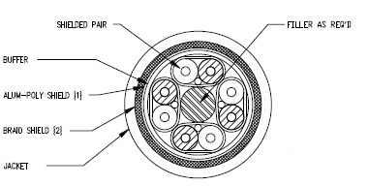

**Figure 1 – Cable Cross Section**

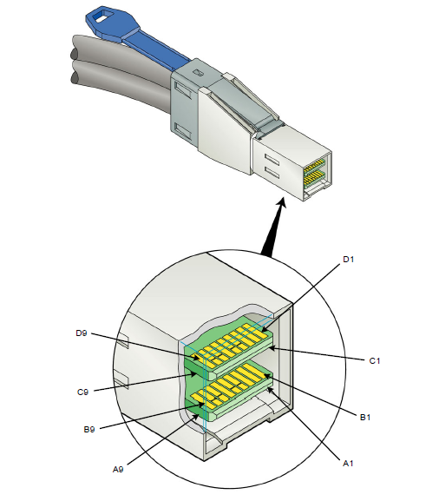



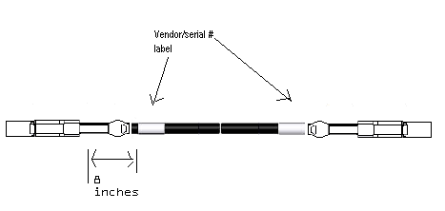

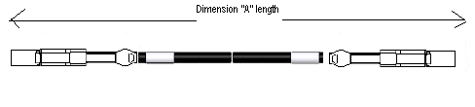



**Figure 2 – Cable Assembly Drawing**

## Cable Binding

The cable should be well joined together. In other words, every 0.5 meter shall bind the 2 cables together so they don’t get tangled. Some acceptable means are tape, glue, heat shrink, all black to match cable color.

## Cable Assembly Construction

Both ends of the assembly will have their jacket strain relief secure enough to withstand the cable strength test, including the dynamic cable flex test performed in accordance with EIA-364-41C and the bend radius pull strength test. Both ends will secure the braid to the shell with a 360 degree connection.

## PCB Construction

• PCB requirements (Reference EMC-ES-1108)

• IPC class 3 plating on all transition or interface printed circuit boards (PCBs)

-1 mil absolute minimum plating copper thickness

• All PCB plated thru holes will be a minimum of 0.010 inches unfinished (drill size) in diameter

• Laser vias will be a minimum of 0.008 inches

Contacts will be a minimum of 30 microinches of gold over minimum 50 microinches of nickel.

• All PCB fabrication material will be designed to High Tg lead free soldering temperatures i.e. FR408HR, Nelco 4000-13, TUC 752.

• Minimum 250 cycles.

• Airgap tolerances 5 mil minimum spacing between etches on outer layers

• Airgap tolerances 4 mil minimum spacing between etches on inner layers

• It is recommended that solder mask is not used to tent via holes due to micro etch entrapment conditions causing poor plating and reliability concerns.

• The solder mask should not encompass any gold plating on the PCBs.

## Cable strain relief/ over mold length requirements

The cable will have some sort of strain relief from the back of the plug shell, the maximum distance that is allowed is 0.5 inches of strain relief mechanism.

## Pull tab

The Pull tab length shall be between 2.25 inch and 4 inches from back shell to end of pull tab. See dimension “Z” in Figure 3.

Pull tabs must be able to withstand a 20lb weight being swung on a pendulum in an arc from 0 to 90 degrees without deformation or tearing of pull tab or mechanism. See SFF 8095

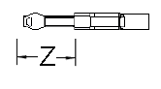

**Figure 3 – Plug Drawing**

## EMI girdle

A EMI girdle shall be present on the mini-sas HD plug according to good EMI practice. It needs to withstand the 250 cycle with no tearing or deformation of the girdle.

## Latch Features

The cable latch needs to have all Burr’s removed on insert edge, and removal edge of latch mechanism contacting the body of the connector shell, tumble latch, remove roughness on bottom surface of latch.

## Pull force

The cable needs to maintain attachment to the latch while being pulled with 20 lbs on the cable. Cable should be able to stay intact as well, no deformation of cage/connector or plug/cable/strain reliefs or electricals.

This applies to this procedure:

• Obtain brand new connector, brand new plug

• Cycle 5 times, plug into same connector

• Leave inserted on the 5 cycle and pull with 20lbs force

• Cable should stay inserted for a minimum of 120 seconds.

• No metal deformation or tearing should occur upon removal of the plug after test is performed on either the plug latch or connector.

## Cable Assembly Management

All cables 1m and longer shall be configure as specified in Figure 4, using 2 ties to loop around the cable.

The diameter of the loop shall be kept at 7 inches +/- 1 inches for cables less than 6M

The diameter of the loop shall be kept at 10 inches +/- 1 inches for cables from 7M and greater

Free end length of a minimum 6 inches.

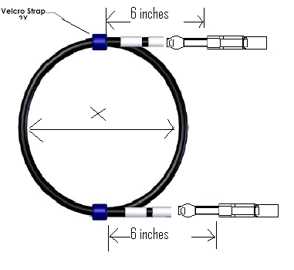

**Figure 4 – Coiled Configuration for 1m cables or longer**

## Connector Plating and Durability

SAS HD connectors are to meet the minimum plating requirements outlined in the GR-1217-CORE specification.

## Wire Connection

See table below for wire connection information:

Table – Wire connection

| **P1 (mini-sas HD)** | |  | **P2 (mini-sas HD)** | |
| --- | --- | --- | --- | --- |
| **Signal** | **Pin #** | **Conductor #** | **Pin #** | **Signal** |
| GND | A9 |  | C9 | GND |
| Rx 1- | A5 | Pair 1 | C5 | Tx 1- |
| Rx 1+ | A4 | C4 | Tx 1+ |
| GND | A3 |  | C3 | GND |
| Rx 3- | A8 | Pair 3 | C8 | Tx 3- |
| Rx 3+ | A7 | C7 | Tx 3+ |
| GND | A6 |  | C6 | GND |
| N/C | A1 | No Thru connection | C1 | SCL |
| Interrupt | A2 | C2 | SDA |
| GND | B9 |  | D9 | GND |
| Rx 0- | B5 | Pair 0 | D5 | Tx 0- |
| Rx 0+ | B4 | D4 | Tx 0+ |
| GND | B3 |  | D3 | GND |
| Rx2- | B8 | Pair 2 | D8 | Tx2- |
| Rx2+ | B7 | D7 | Tx2+ |
| GND | B6 |  | D6 | GND |
| N/C | B1 | No Thru connection | D1 | N/C |
| Mod_PRS_L (GND) | B2 | D2 | V+3.3 for EEPROM |
| GND | C9 |  | A9 | GND |
| Tx 1- | C5 | Pair 5 | A5 | Rx 1- |
| Tx 1+ | C4 | A4 | Rx 1+ |
| GND | C3 |  | A3 | GND |
| Tx 3- | C8 | Pair 7 | A8 | Rx 3- |
| Tx 3+ | C7 | A7 | Rx 3+ |
| GND | C6 |  | A6 | GND |
| SCL | C1 | No Thru connection | A1 | N/C |
| SDA | C2 | A2 | Interrupt |
| GND | D9 |  | B9 | GND |
| Tx 0- | D5 | Pair 4 | B5 | Rx 0- |
| Tx 0+ | D4 | B4 | Rx 0+ |
| GND | D3 |  | B3 | GND |
| Tx 2- | D8 | Pair 6 | B8 | Rx 2- |
| Tx 2+ | D7 | B7 | Rx 2+ |
| GND | D6 |  | B6 | GND |
| N/C | D1 | No Thru connection | B1 | N/C |
| V+3.3 for EEPROM | D2 | B2 | Mod_PRS_L (GND) |
| Shell | Braid | | | Shell |

# ENVIRONMENTAL REQUIREMENTS

## Temperature Life

Perform in accordance with EIA 364-17, Method A, test condition 4. Cable and board connector shall remain mated without any electrical load and following details shall apply: • Temperature: 105°C ± 2°C • Duration: 840 hours • No changes in contact resistance greater than 10mΩ

## Temperature Life Preconditioning

Perform in accordance with EIA 364-17, Method A, test condition 4. Cable and board connector shall remain mated without any electrical load. The following details shall apply:

•Temperature: 105°C ± 2°C

• Duration: 336 hours

## Thermal Shock

Perform in accordance with EIA 364-32, method A, condition 1, duration A-3. The following details shall apply:

• Number of cycles: 100

• Temperature range: -55 to + 85oC

•Time at each temperature: 30 minutes minimum

• Transfer time: 30 seconds maximum

## Cyclical Humidity and Temperature

Samples are to be exposed to cyclical humidity and temperature in accordance with EIA 364-31, Method III, except for profile and duration as follows. Samples are to be subjected to 50 cycles of 10 hour duration for a total of 500 hours.

A cycle consists of the following steps:

• 2 hour ramp from 25°C to 65°C at 90 % to 98 % RH

• 4 hour dwell at 65°C, 90 % to 98 % RH

• 2 hour ramp down from 65°C to 25°C at 80 % to 98 % RH

• 2 hour dwell at 25°C, 90 % to 98 % RH

## Mechanical Vibration

Perform in accordance with EIA 364-28, Test Condition 7D. Mated samples are subjected to 3.1 G rms between 20 and 500 Hz for 15 minutes in each of 3 mutually perpendicular planes. Both mating halves of samples are to be rigidly mounted. No discontinuities greater than 1 micro-second are to occur during testing. The maximum change in contact resistance shall be less than 10 mΩ.

## Mixed Flowing Gas (MFG)

Perform in accordance with EIA 364-65. Unmated board connectors shall be subjected to environmental class IIA gas exposure for 224 hours with half of the samples mated, and half unmated (receptacle exposed) followed by an additional 112 hours with all samples mated.

## Thermal Disturbance

Samples are to be cycled 10 times between 15±3ºC and 85±3ºC. Ramp rate shall be a minimum of 2ºC per minute. Dwell time shall be a minimum of 5 minutes at each temperature extreme.

## Reseat

Manually unmate and remate the connector pair 3 times.

## Connector Repair

Connector repair is conducted in accordance with IEC 60352-5, Section 5.2.2.6. After initial connector insertion, the connector is removed and replaced with a new connector (in the same PTHs). This second connector is removed and replaced with a new connector (in the same PTHs). This third connector is left in place on the printed wiring board for assessment of PTH integrity (radial deformation, remaining copper thickness, and wall damage) or is removed for measurement of final press fit retention force. There shall be no damage to the printed wiring board detrimental to function.

# QUALITY ASSURANCE PROVISONS

## 10.1 Equipment Calibration

All test equipment and inspection facilities used in the performance of any test shall be maintained in a calibration system in accordance with Mil-C-45622.

## 10.2 Inspection Conditions

Unless otherwise specified herein, all inspections shall be performed under the following ambient conditions:

• Temperature: 25 ± 5° C.

• Relative Humidity: 20% to 60%

• Barometric pressure: Local ambient

# S-PARAMETER REQUIREMENT OF 12G SAS

FOR Reference ONLY: Taken from The 802.3BA specification to calculate the fitted insertion loss.

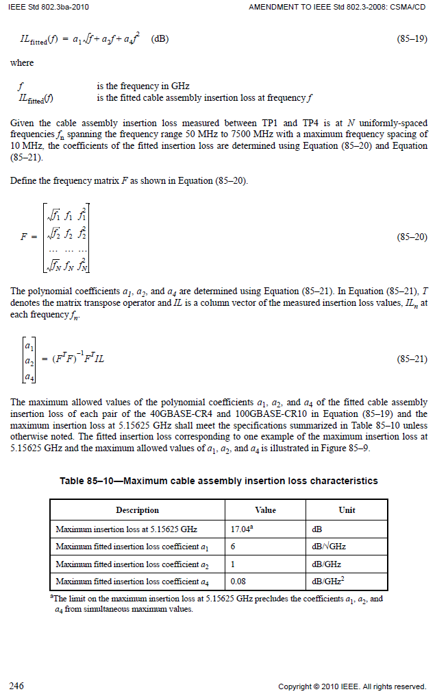



## 12G SDD21 – Insertion Loss Specification.

***SDD21 measurement should be de-embeded with 2X calibration structure.***

Insertion Loss for Passive Cable Assembly is specified by the curve fit equation:

**IL(*f*)fit = a1*sqrt(*f*) + a2\**f* + a4\**f^*2, 50MHz < *f(GHz)* < 9GHz (**Eq. 1)

The curve fit is performed over the frequency range, 50MHz < *f* < 9GHz.

The maximum values for a1, a2, and a4 are shown below:

|  |  |
| --- | --- |
| Insertion Loss Curve Fit Coefficient | Maximum Value of Coefficient |
| a1 | -1.7 |
| a2 | -0.3 |
| a4 | -0.044 |

Table 7 – Insertion Loss Coefficients for 1M

|  |  |
| --- | --- |
| Insertion Loss Curve Fit Coefficient | Maximum Value of Coefficient |
| a1 | -3.2 |
| a2 | -0.13 |
| a4 | -0.065 |

Table 8 – Insertion Loss Coefficients for 2M

|  |  |
| --- | --- |
| Insertion Loss Curve Fit Coefficient | Maximum Value of Coefficient |
| a1 | -3.62 |
| a2 | -0.35 |
| a4 | -0.05 |

Table 9 – Insertion Loss Coefficients for 3M

|  |  |
| --- | --- |
| Insertion Loss Curve Fit Coefficient | Maximum Value of Coefficient |
| a1 | -3.9 |
| a2 | -0.15 |
| a4 | -0.042 |

Table 10 – Insertion Loss Coefficients for 4M

|  |  |
| --- | --- |
| Insertion Loss Curve Fit Coefficient | Maximum Value of Coefficient |
| a1 | -4.2 |
| a2 | -0.55 |
| a4 | -0.03 |

Table 11 – Insertion Loss Coefficients for 5M

|  |  |
| --- | --- |
| Insertion Loss Curve Fit Coefficient | Maximum Value of Coefficient |
| a1 | TBD |
| a2 | TBD |
| a4 | TBD |

Table 12 – Insertion Loss Coefficients for 6M

|  |  |
| --- | --- |
| Insertion Loss Curve Fit Coefficient | Maximum Value of Coefficient |
| a1 | TBD |
| a2 | TBD |
| a4 | TBD |

Table 13 – Insertion Loss Coefficients for 7M

|  |  |
| --- | --- |
| Insertion Loss Curve Fit Coefficient | Maximum Value of Coefficient |
| a1 | TBD |
| a2 | TBD |
| a4 | TBD |

Table 14 – Insertion Loss Coefficients for 8M

## 12G ILD – Insertion Loss Deviation Specification.

***SDD21 measurement should be de-embeded with 2X calibration structure.***

Insertion Loss Deviation is defined as the difference between the fitted insertion loss and the measured insertion loss of the cable assembly:

**ILD(*f*) = IL(*f*)fit – IL(*f*)measured, where 50MHz < *f(GHz)* < 9GHz (**Eq. 2)

The specification for the insertion loss deviation is given below:

**ILD (*f*) LOWER = ‐0.5 – 0.0715\**f* where 50MHz < *f(GHz)* < 6GHz (**Eq. 3)

**ILD (*f*) LOWER = ‐0.5 – .143\**f* where 6GHz < *f(GHz)* < 9GHz (**Eq. 4)

**ILD (*f*) UPPER = 0.5 + 0.0715\**f* where 50MHz < *f(GHz)* < 6GHz (**Eq. 5)

**ILD (*f*) UPPER = 0.5 + 0.143\**f* where 6GHz < *f(GHz)* < 9GHz (**Eq. 6)

Figure 1 – SAS 12G Insertion Loss Deviation Limits

## 12G SDDXX - Passive Cable Assembly Differential Return Loss

**SDDxx (dB) < ‐12, where 50MHz < *f(GHz)* < 6GHz (**Eq. 7)

**SDDxx (dB) < ‐12 + 20*log(*f*/6), where 6 < *f(GHz)* < 9GHz (**Eq. 8)

Figure 2 – SAS 12G Differential Return Loss

## 12G SCD21 - Passive Cable Assembly Mode Conversion

**SCD21 (dB) < ‐20dB, where 50MHz < *f(GHz)* < 9GHz (**Eq. 9)

Figure 3 – 12G Mode Conversion

## 12G SCD21(dB) – SDD21(dB) Passive Cable Assembly Mode Conversion – Insertion Loss

***SDD21 measurement should be de-embeded with 2X calibration structure.***

**SCD21 (dB) – SDD21 (dB) < ‐10dB, where 50MHz < *f(GHz)*< 9GHz (**Eq. 10)

Figure 4 – 12G Mode conversion – Insertion loss

## 12G ICR – Insertion Loss to Crosstalk Ratio

***SDD21 measurement should be de-embeded with 2X calibration structure.***

Insertion loss to crosstalk ratio is specified as:

**ICR (dB) < ‐23 + 18.7*log (*f*/6), where 50MHz < *f(GHz)* < 9GHz (**Eq. 11)

Figure 5 – 12G ICR

## 12G ICN – Integrated Crosstalk Noise

***The calculation of Integrated Crosstalk Noise is borrowed from IEEE 802.3ba Section 85.10.7***

**σx, ca < 10mV, for 3 < IL < 5.3 (**Eq. 12)

**σx, ca < 12.4 – 0.45*IL, for 5.3 < IL < 17 (**Eq. 13)

The ICN parameters for 12G passive cable assemblies are shown in the table below:

|  |  |  |  |
| --- | --- | --- | --- |
| Description | Value | Symbol | Units |
| Symbol Rate | 12 | *fb* | Gbd |
| Near‐end disturber peak differential output amplitude | 600 | *Ant* | mV |
| Far‐end disturber peak differential output amplitude | 600 | *Aft* | mV |
| Near‐end disturber 20% to 80% rise and fall time | 17 | *Tnt* | ps |
| Far‐end disturber 20% to 80% rise and fall time | 17 | *Tft* | ps |
| 3dB Reference Receiver Bandwidth | 0.75 * fb | *fr* | GHz |

The crosstalk is integrated over the frequency range, 50MHz < *f* < 12GHz



BAD

GOOD

Figure 6 – 12G ICN

# SUPPORTING INFORMATION

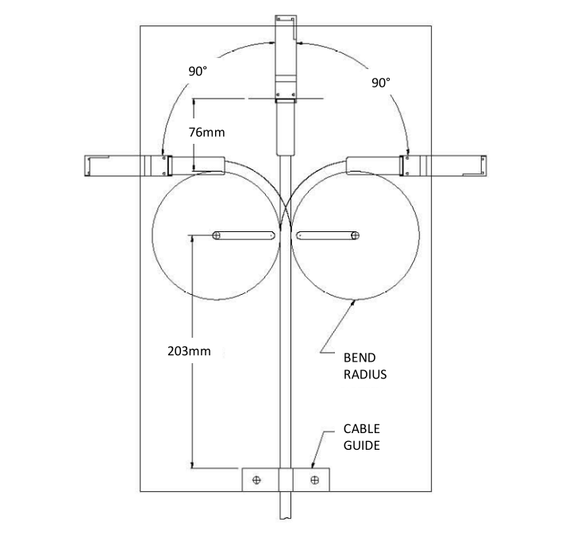

Repeated Wire Flex Test (See Mechanical Characteristics 8.2)

# LABELING AND PACKING

## Labeling position

Labels are adhered to two ends of cable as figure 1 shown,

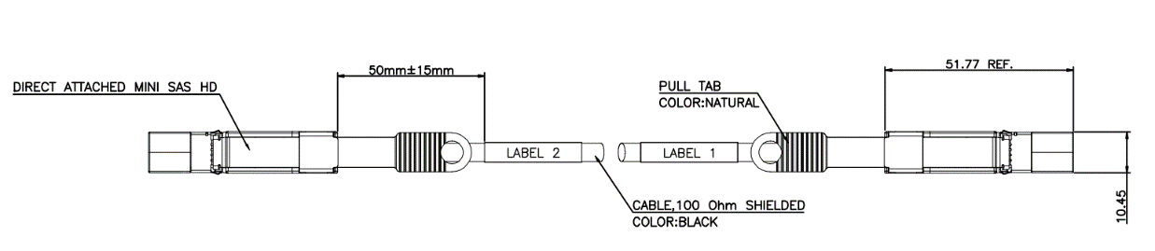

Figure 1 Labeling position

## Label information

The information on the label must tell the part number of customer, week code of production, description of the cable assembly and barcode for tracking. See figure 2

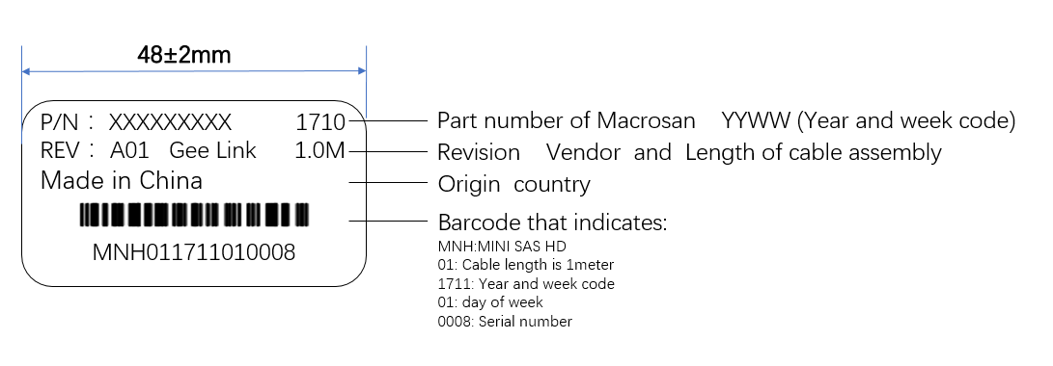

**Figure 2 Label information**

## Packing

Cable assemblies must be wrapped by [antistatic bag](javascript:;) and the outer label must have the UL logo that the cable commit.

Packing labels are to be determined. See below pictures for reference

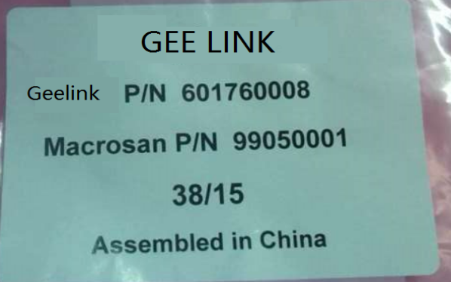 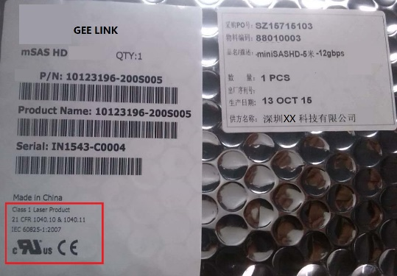

# REVISION RECORD

|  |  |  |  |
| --- | --- | --- | --- |
| **REV** | **PAGE** | **DESCRIPTION** | **DATE** |
| **A0** | Initial Release | Initial Release | 2016/09/16 |
| **A1** | 31 & 32 | Add more details on labeling and packing | 2017/03/14 |
|  |  |  |  |
|  |  |  |  |